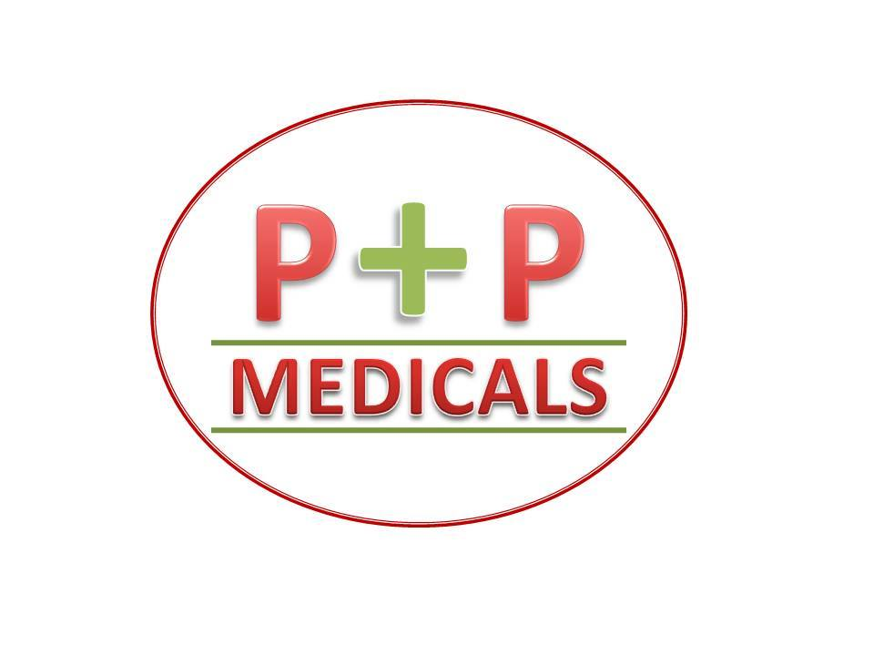

PRAVEEN PHARMACY & MEDICALS

1. HOME
2. MANAGING DIRECTOR’S MESSAGE
3. MISSION & VISSION
4. ABOUT ORGANISATION
5. ASSOCIATIONS & SCOPE & PORTFOLIO
6. PPM SURGICALS

PRODUCT’S CATALOUGE

ENQUIRY FORM

1. PPM CONSULTANCY

CONSULTANCY PORTFOLIO

GET IN TOUCH FORM

1. PPM CONSTRUCTIONS

CIVIL CONSTRUCTION

ARCHITECTURE & STRUCTURAL DESIGNS

INTERIOR DESIGNING

ASSOCIATE FORM

1. PPM EVENT MANAGEMENT

SERVICES PROFILE

CALL FORM

1. GENERAL RULES & REGULATIONS
2. ACHIVEMENT’S GALLERY
3. CONTACT US